Up Close Images

Metal under a microscope
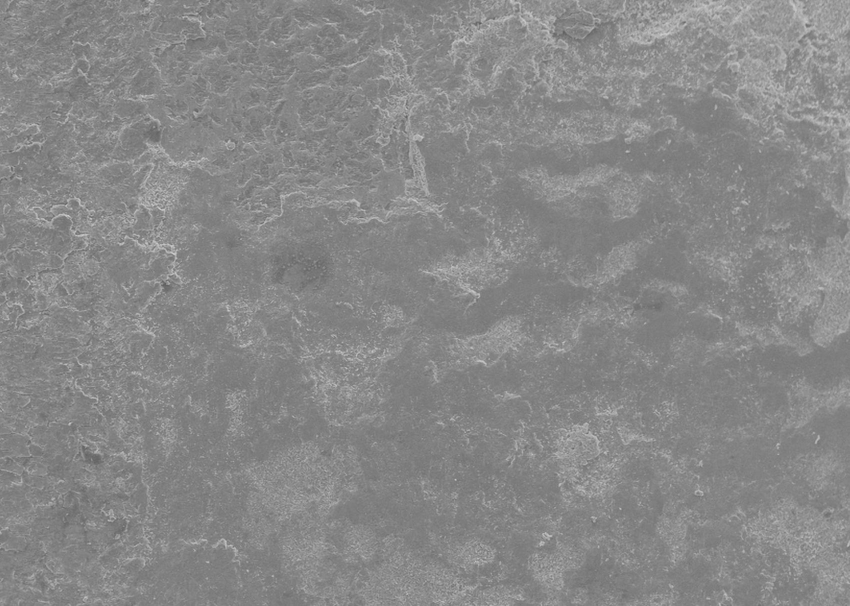
Mariolav / Shutterstock

Cotton fabric up close
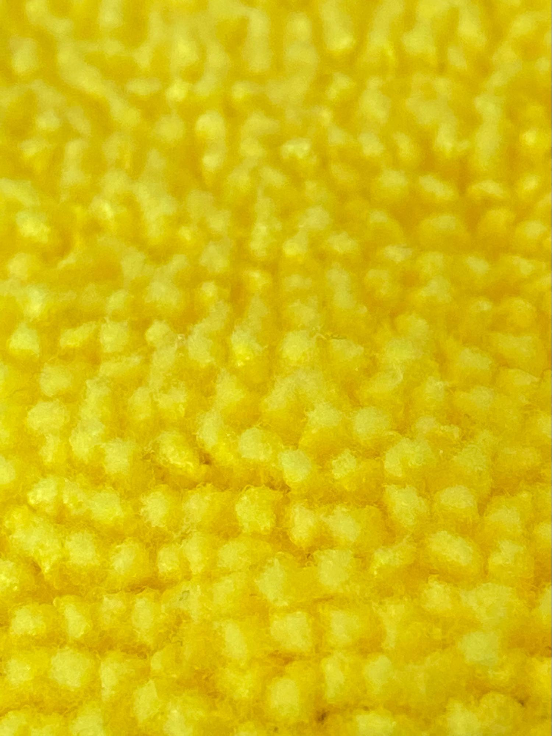

Cotton fibers under a microscope
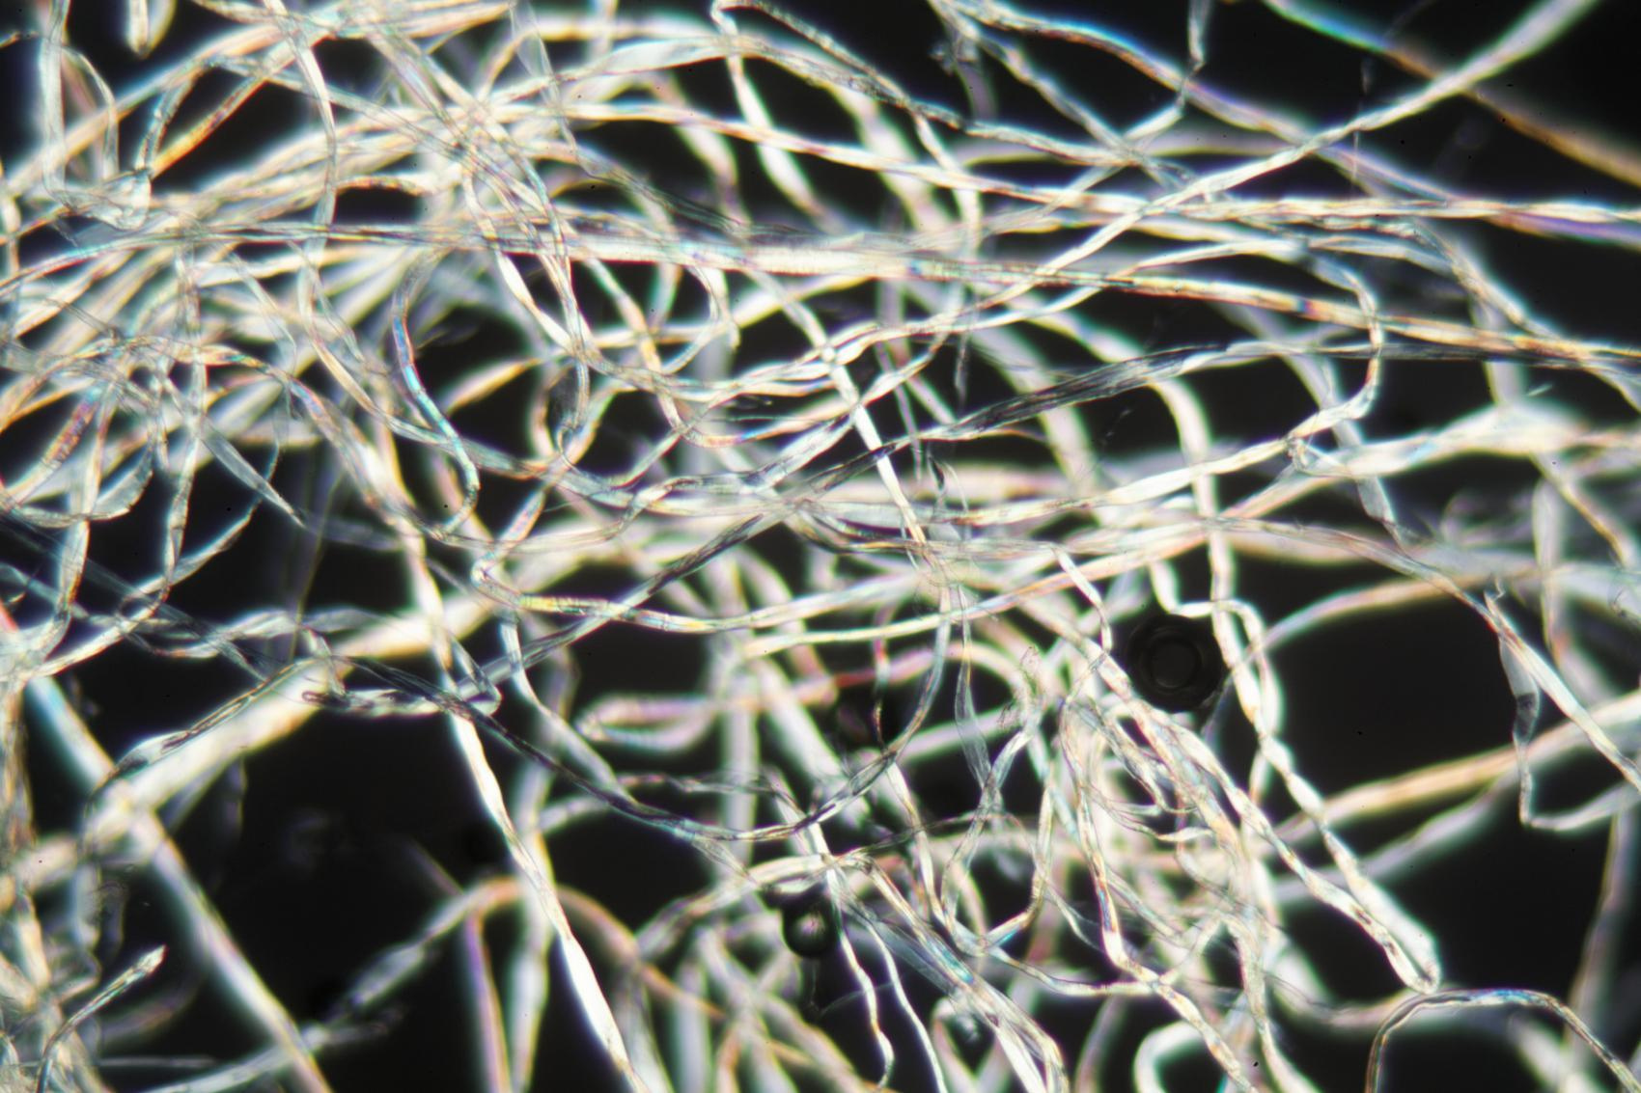
weisschr

Styrofoam under a scanning electron microscope
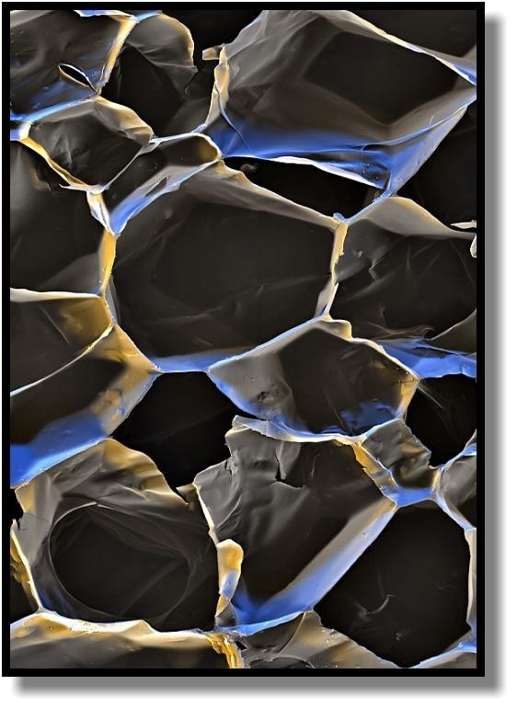
Stefan Diller - Scientific Photography, Germany 2019

Bubble wrap up close
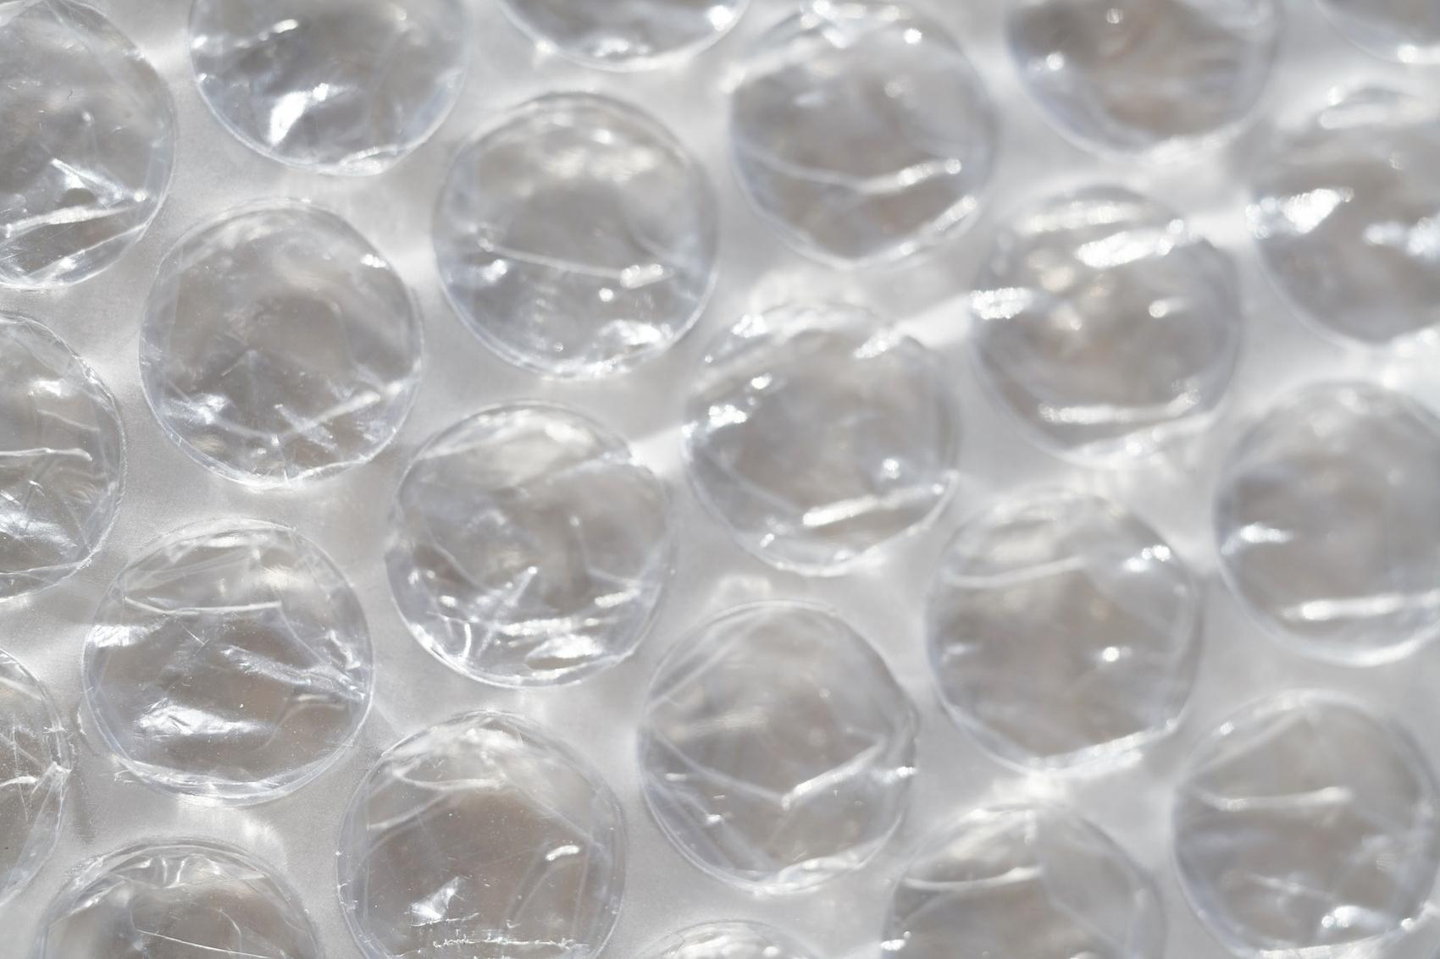

Foam earplugs up close
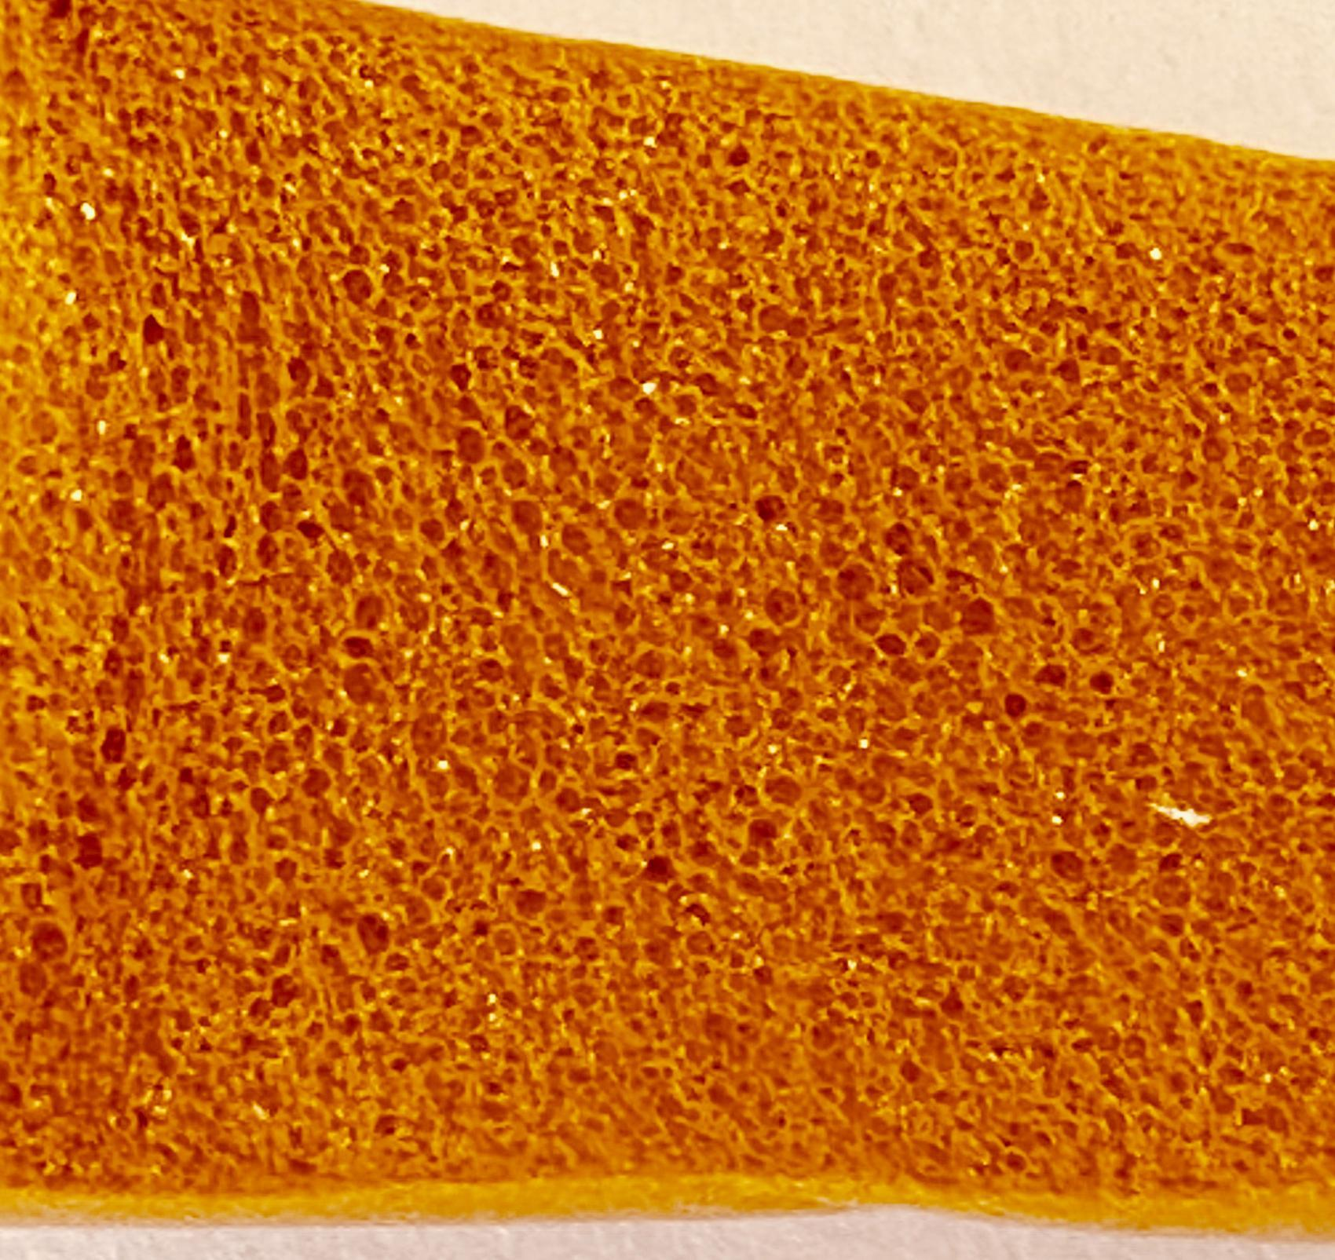

Corrugated cardboard up close
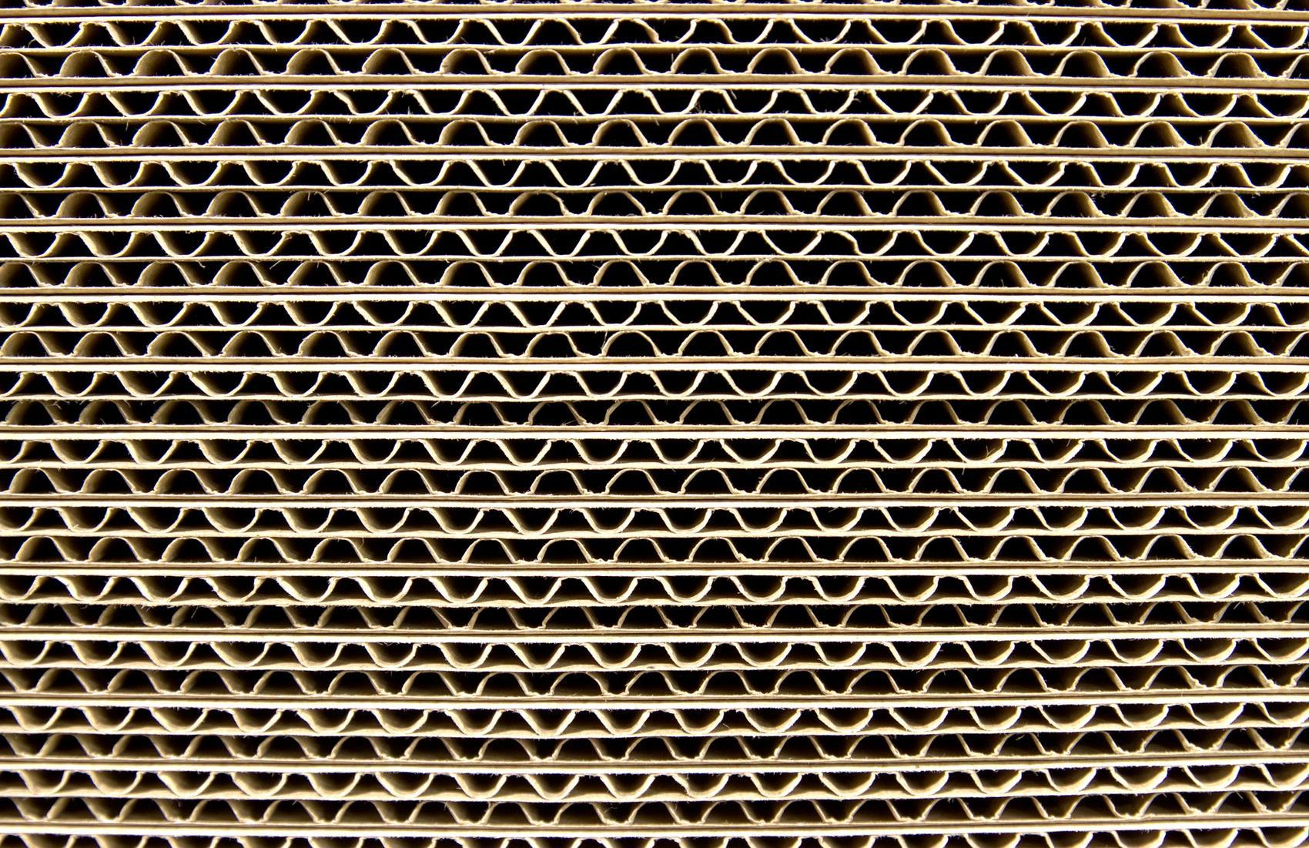

Lightweight wood under a microscope
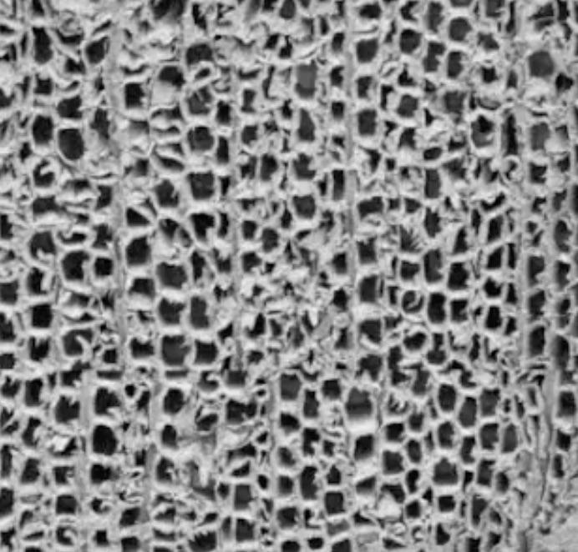
Reprinted from International Journal of Solids and Structures, 44, Silva, A. & Kiriakides, S., Compressive response and failure of balsa wood, 33, 2007, with permission from Elsevier. Rights reserved.

